**The task to be performed:**

1. Create a database named employee, then import **data_science_team.csv** **proj_table.csv** and **emp_record_table.csv** into the **employee**database from the given resources.

->create database employee;

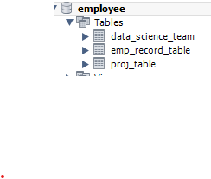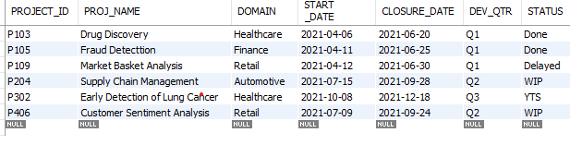 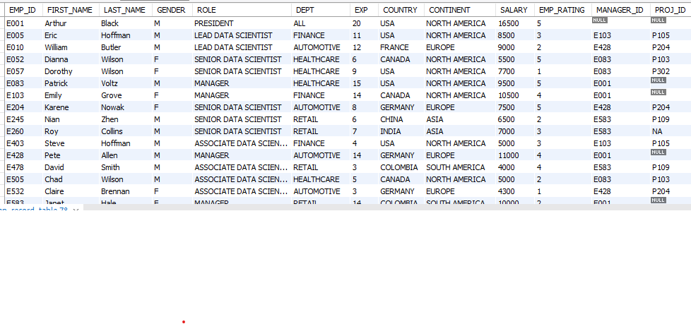 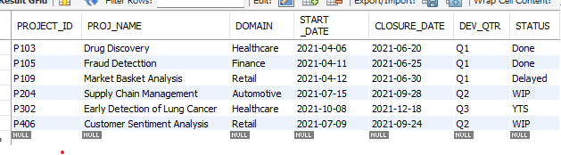

1. Create an ER diagram for the given **employee**database.

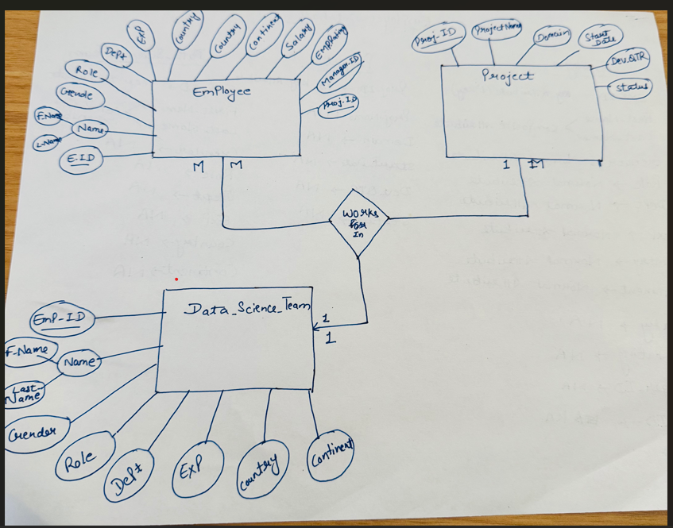

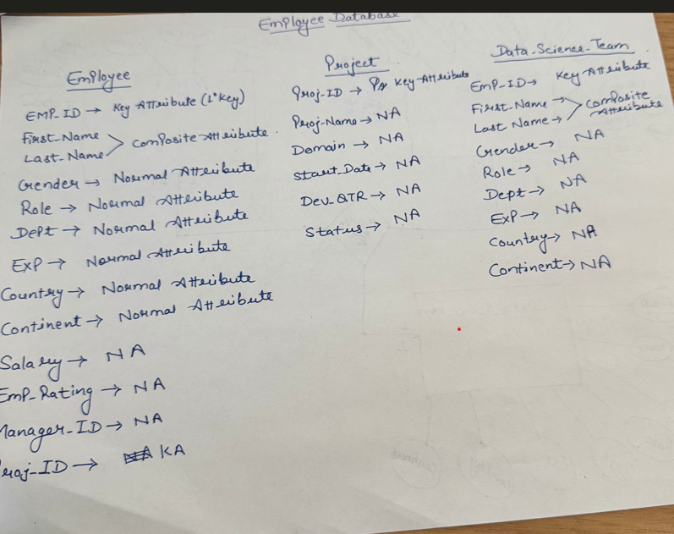

1. Write a query to fetch EMP_ID, FIRST_NAME, LAST_NAME, GENDER, and DEPARTMENT from the employee record table, and make a list of employees and details of their department.

-> select emp_id,First_name,Last_name,Gender,dept

from emp_record_table;

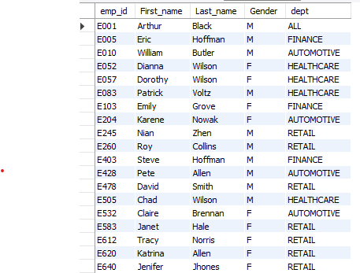

1. Write a query to fetch EMP_ID, FIRST_NAME, LAST_NAME, GENDER, DEPARTMENT, and EMP_RATING if the EMP_RATING is:

* less than two
* greater than four
* between two and four
* select emp_id,First_name,Last_name,Gender,dept, Emp_rating

from emp_record_table

where emp_rating <2;

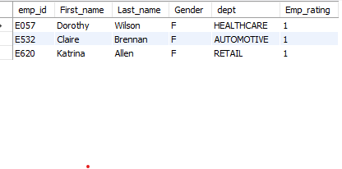

* select emp_id,First_name,Last_name,Gender,dept, Emp_rating

from emp_record_table

where emp_rating >4;

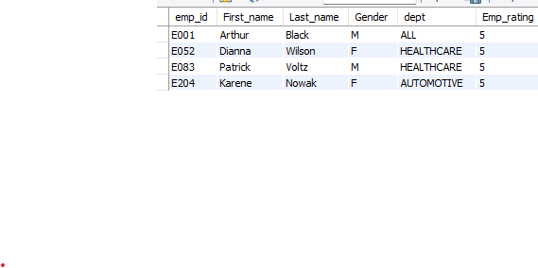

* select emp_id,First_name,Last_name, Gender,dept, Emp_rating

from emp_record_table

where emp_rating between 2 and 4;

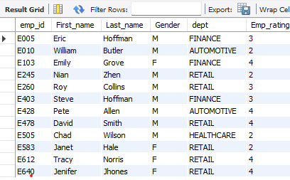

1. Write a query to concatenate the FIRST_NAME and the LAST_NAME of employees in the Finance department from the employee table and then give the resultant column alias as NAME.

* SELECT dept, CONCAT(First_name, ' ', Last_Name) AS resultant

FROM emp_record_table

WHERE dept = 'finance';

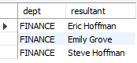

1. Write a query to list only those employees who have someone reporting to them. Also, show the number of reporters (including the President).

-> select Emp_record_table.EMP_id,Emp_record_table.role,data_science_team.emp_id,data_science_team.First_name

from emp_record_table

inner join data_science_team

on emp_record_table.emp_id = data_science_team.emp_id;

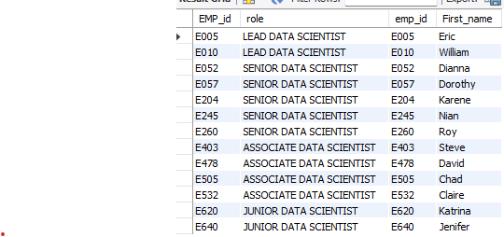

1. Write a query to list down all the employees from the healthcare and finance departments using union. Take data from the employee record table.

* select First_name, LAst_name, dept from emp_record_table

where dept = 'healthcare'

union

select First_name, LAst_name, dept from emp_record_table

where dept = 'finance';

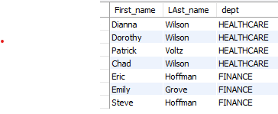

1. Write a query to list down employee details such as EMP_ID, FIRST_NAME, LAST_NAME, ROLE, DEPARTMENT, and EMP_RATING grouped by dept. Also include the respective employee rating along with the max emp rating for the department.

select Emp_Id, First_name,Last_Name, Role, Dept, max(EMP_RATING) as max_emp_rating from emp_record_table

group by Emp_Id, First_name,Last_Name, Role, Dept;

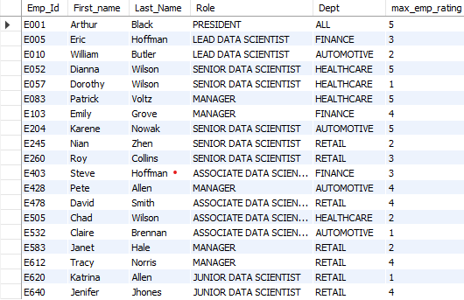

1. Write a query to calculate the minimum and the maximum salary of the employees in each role. Take data from the employee record table.

* SELECT ROLE, MIN(SALARY) AS MIN_SALARY, MAX(SALARY) AS MAX_SALARY FROM emp_record_table

GROUP BY role;

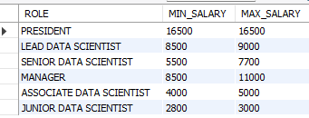

1. Write a query to assign ranks to each employee based on their experience. Take data from the employee record table.

-> SELECT Emp_id, exp, RANK() OVER (ORDER BY exp DESC) AS ranks FROM emp_record_table;

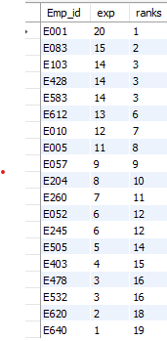

1. Write a query to create a view that displays employees in various countries whose salary is more than six thousand. Take data from the employee record table.

-> create view view_emp as

select emp_id,country,salary from emp_record_table

where salary>6000;

select * from view_emp;

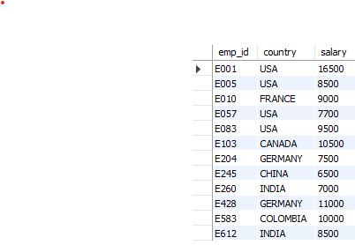

1. Write a nested query to find employees with experience of more than ten years. Take data from the employee record table.

-> select emp_Id, exp,

case

when exp > 10 then ' More than 10 Year of Experience'

else

'less than 10 year of experience'

end as Total_experience

from emp_record_table;

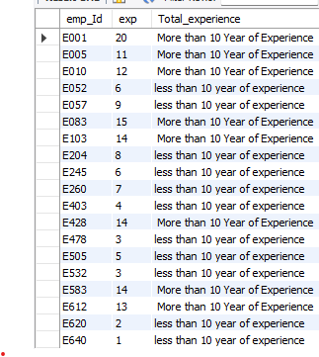

1. Write a query to create a stored procedure to retrieve the details of the employees whose experience is more than three years. Take data from the employee record table.

* DELIMITER $$

USE `employee`$$

CREATE PROCEDURE `get_experience_details` ()

BEGIN

select emp_id,exp from emp_record_table

where exp > 3;

END$$

DELIMITER;

call get_experience_details();

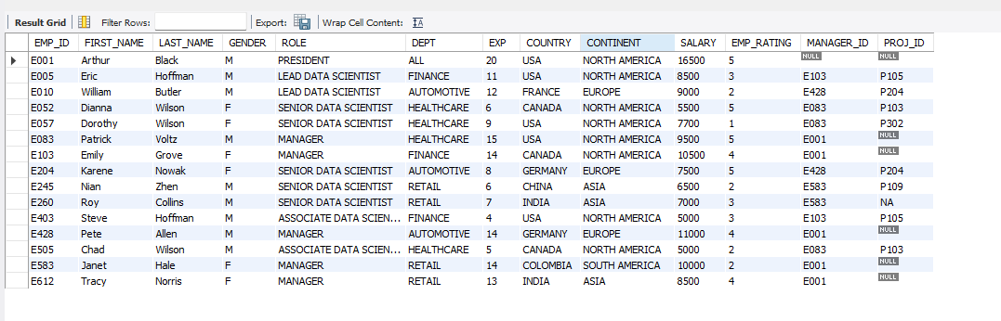

1. Write a query using stored functions in the project table to check whether the job profile assigned to each employee in the data science team matches the organization’s set standard.

The standard being:

For an employee with experience less than or equal to 2 years assign 'JUNIOR DATA SCIENTIST',

For an employee with the experience of 2 to 5 years assign 'ASSOCIATE DATA SCIENTIST',

For an employee with the experience of 5 to 10 years assign 'SENIOR DATA SCIENTIST',

For an employee with the experience of 10 to 12 years assign 'LEAD DATA SCIENTIST',

For an employee with the experience of 12 to 16 years assign 'MANAGER'.

* DELIMITER $$

CREATE FUNCTION checkJobProfile(experience INT, role VARCHAR(100))

RETURNS VARCHAR(100)

returns int

DETERMINISTIC

BEGIN

DECLARE expected_role VARCHAR(100);

IF experience <= 2 THEN expected role = 'junior data scientist';

select role into expected_role from employee.data_science_team where exp = experience;

IF experience between 2 and 5 THEN expected role = 'Associate data scientist';

select role into expected_role from employee.data_science_team where exp = experience;

IF experience between 5 and 10 THEN expected role = 'Senior data scientist';

select role into expected_role from employee.data_science_team where exp = experience;

IF experience between 10 and 12 THEN expected role = 'Lead data scientist';

select role into expected_role from employee.data_science_team where exp = experience;

IF experience between 12 and 16 THEN expected role = 'Manager';

select role into expected_role from employee.data_science_team where exp = experience;

ELSE

SET expected_role = 'not exist';

END /

DELIMITER ;

* select checkjobprofile(1);



1. Create an index to improve the cost and performance of the query to find the employee whose FIRST_NAME is ‘Eric’ in the employee table after checking the execution plan.

-> CREATE INDEX idx_first_name ON emp_record_table(FIRST_NAME);

select * from emp_record_table where first_name = 'Eric';



1. Write a query to calculate the bonus for all the employees, based on their ratings and salaries (Use the formula: 5% of salary * employee rating).

-> SELECT

EMP_ID,

FIRST_NAME,

LAST_NAME,

SALARY,

EMP_RATING,

CASE

WHEN EMP_RATING > 0 THEN Round(0.05 * SALARY * EMP_RATING, 2)

ELSE 0

END AS BONUS

FROM emp_record_table;

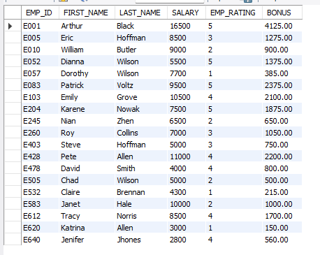

1. Write a query to calculate the average salary distribution based on the continent and country. Take data from the employee record table.

-> SELECT

CONTINENT,

COUNTRY,

CASE

when COUNTRY = 'USA' AND CONTINENT = 'North America' then avg(salary)

WHEN country = 'CANADA' and Continent = 'North America' tHEN avg(salary)

WHEN country = 'france' and Continent = 'Europe' tHEN avg(salary)

WHEN country = 'Germany' and Continent = 'Europe' then avg(salary)

WHEN country = 'China' and Continent = 'Asia' then avg(salary)

WHEN country = 'India' and Continent = 'Asia' then avg(salary)

WHEN country = 'colombia' and Continent = 'South America' then avg(salary)

ELSE NULL

END AS AVG_SALARY

FROM emp_record_table

group by continent, country

